Answer By Fran Maekel

# #Readme

1. Please answer the following questions in a separate document
2. Push all your answers to your github account
3. Invite these github accounts: @arsoedjono and @7etrahedral
4. Send an email informing that you have finished the test to [ferina@bukalapak.com](mailto:ferina@bukalapak.com), cc [genta.wibowo@bukalapak.com](mailto:genta.wibowo@bukalapak.com), [aranda.rizki@bukalapak.com](mailto:aranda.rizki@bukalapak.com).

# Basic Programming

1. What is the data-type usually used in arithmetic operation?

Answer : integer

1. What is the data-type usually used in word and character?

Answer : string

1. What is the output of code below

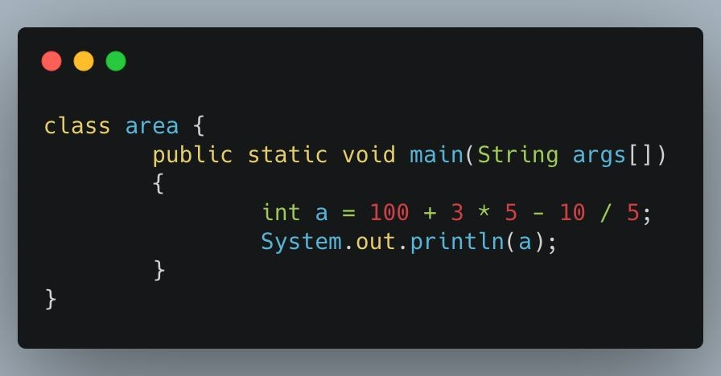

Answer : 113

1. What is the output of code below

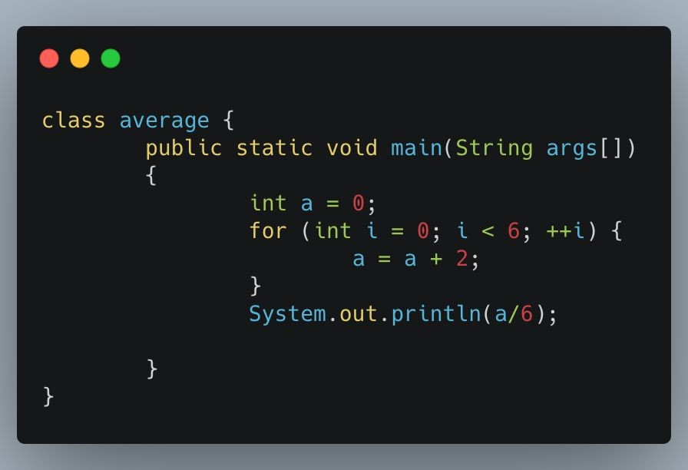

Answer : 2

1. What is the output of code below

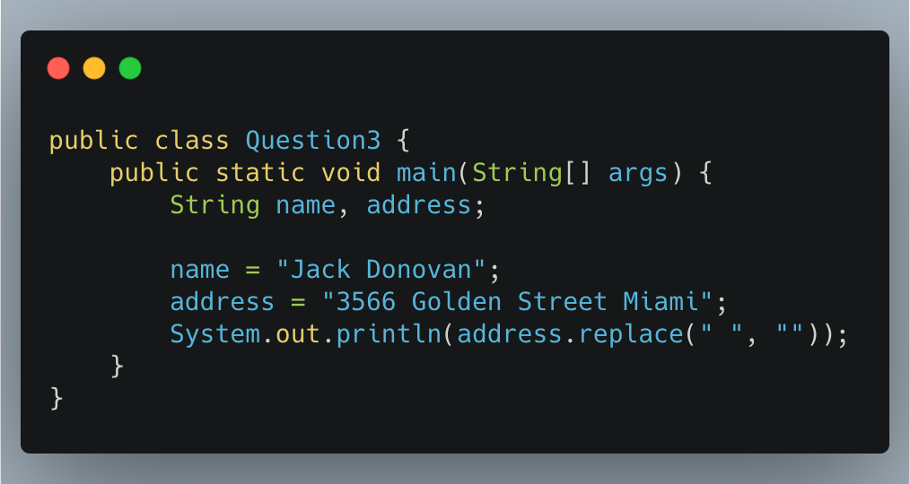

Answer : 3566GoldenStreetMiami

# Flaky Test

1. What is a flaky test?

Answer :  **flaky test** is a **test** that both passes and fails periodically without any code changes.

1. An element in a website is using ajax/javascript to show the data (processed as asynchronous). What do you do to test that element?

Answer :

- Create Object Ajax

- Handler Function

- Make a sure Method & URL

- Send the request

1. A website page can only be accessed with CAPTCHA. How do you test that page?

Answer :

1. Ensure that the system accepts valid **Captcha**.
2. Ensure that the system rejects the invalid **Captcha**.
3. Ensure that the **Captcha** code resets as the system reloads.
4. Ensure that the **Captcha** changes as the user enters wrong value.

# Essay Question Topic

We would be very appreciated if you answer the questions below by not using Katalon and Postman

1. Create automation test script to test these end-point:
   1. GET -> <https://jsonplaceholder.typicode.com/posts>-> To make sure this end-point have a correct data-type below:
      * userId -> Integer
      * id -> Integer
      * title -> String
      * body -> String
   2. 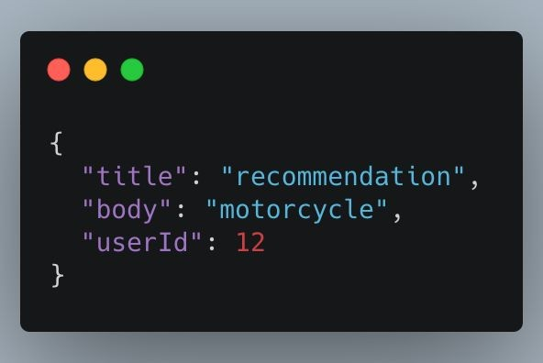POST -> <https://jsonplaceholder.typicode.com/posts>-> To make sure this end-point get a correct response compare with the input data:
2. Create automation test script to test 1 of these scenarios using Bukalapak website:
   1. Register
   2. Login
   3. Add to Cart
   4. Search Product
3. Download this apk:

[https://apkpure.com/sample-android-app-login-test/com.loginmodule.learning/download?](https://apkpure.com/sample-android-app-login-test/com.loginmodule.learning/download?from=details) [from=details](https://apkpure.com/sample-android-app-login-test/com.loginmodule.learning/download?from=details)

Create and automation test (positive and negative)for apps with 1 of these scenarios:

* 1. Register
  2. Login